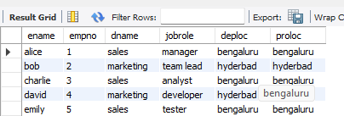

## **More Queries on Insurance Database**

### **Question (Week 6)**

1. Using Scheme diagram, Create tables by properly specifying the primary keys and the foreign keys.
2. Enter greater than five tuples for each table.
3. List the name of the managers with the maximum employees
4. Display those managers name whose salary is more than average salary of his employee.
5. Find the name of the second top level managers of each department.
6. Find the employee details who got second maximum incentive in January 2019.
7. Display those employees who are working in the same department where his manager is working.

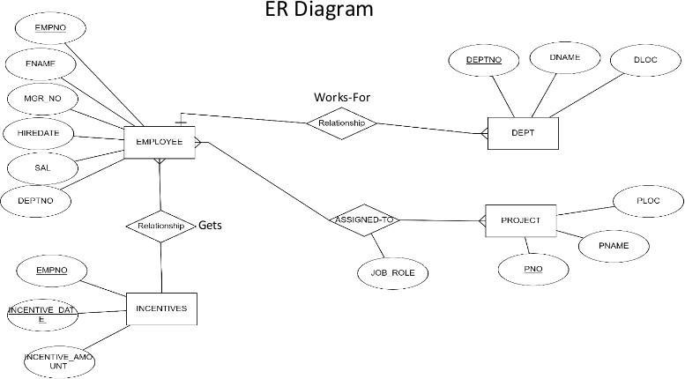

###### **List the name of the managers with the maximum employees**

**select** mgrno as manager_id, **count(**empno) as employeecount **from** employee **group by** mgrno **order by**

employeecount **desc** limit 1;



###### **Display those managers name whose salary is more than average salary of his employee**

**select** m.ename as managername,m.sal **as** managersalary,emp_avg.avg_employee_salary **from** employee m **join** (select mgrno,avg(sal)as avg_employee_salary from employee **group by** mgrno) as emp_avg **on** m.empno=emp_avg.mgrno;

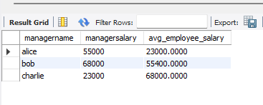

###### **Find the name of the second top level managers of each department.**

**select** ename as secondtopmanager **from**(select m.empno,d.depno,row_number() over(partition by d.depno **order by** m.sal desc) as rank1 **from** employee m **join** dept d on m.depno=d.depno **where** m.mgrno is null) as rankedmanagers **where** rank1=2;

###### **Find the employee details who got second maximum incentive in January 2019**

select e.empno,e.ename,e.sal, e.depno from employee e join incentives i on e.empno=i.empno where i.incentive_date between '2022-11-10' and '2024-12-10' order by i.incentive_amount desc limit 1 offset 1;



###### **Display those employees who are working in the same department where his manager is working.**

**select** e.ename as employeename **from** employee e **join** employee m **on** e.mgrno=m.mgrno **where**

e.depno=m.depno;

